**Title:** **Drone Distance Calculation in Machine Learning Application**

**Submitted by Tanvir Ehsan**

**Jahangirnagar University**

**Summer internship-2024**

**Drone Distance Calculation in Machine Learning Application**

The haversine formula, an essential equation in navigation, calculates great-circle distances between two points on a sphere based on their latitudes and longitudes.

**Great Circle Distance:**

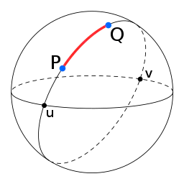

Figure-01

The diagram above depicts the great-circle distance (highlighted in red) between two points on a sphere, namely P and Q. Additionally, the illustration includes two antipodal points, denoted as u and v.

**Table-01**



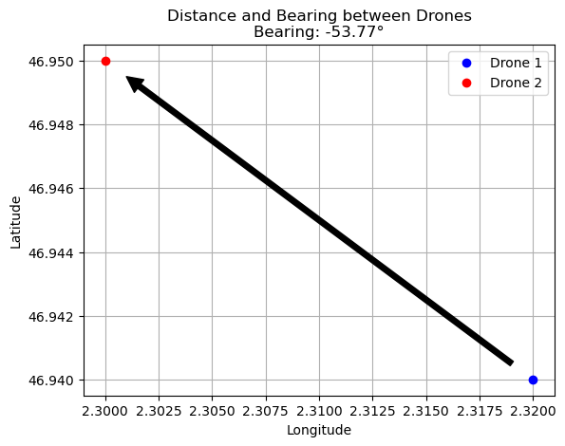

Figure-02

The plot shows the locations of the drones and an arrow indicating the bearing from Drone 1 to Drone 2. Drone 1Latitude is 46.94, Longitude is 2.32. Drone 2 Latitude is 46.95, Longitude is 2.3. In addition, the distance between the two drones is 1881.9 m. The bearing angle between the two drones is-53.77°.

UAV (Unmanned Aerial Vehicle) distance measuring using SFS (Single-Source Shortest Path) and DFS (Depth-First Search) pathfinding methods can be approached in several ways. Here’s a brief overview of each method as well as how they might be applied in the context of UAV navigation:

**SFS (Single-Source Shortest Path)**

**Overview:**

* SFS typically refers to algorithms such as Dijkstra’s or A* that find the shortest path from a source node to a destination node in a weighted graph.

**Application in UAV Navigation:**

1. **Graph Representation:**
   * The environment is represented as a graph where nodes correspond to positions or waypoints and edges represent possible paths between these positions with weights indicating distances or travel costs.

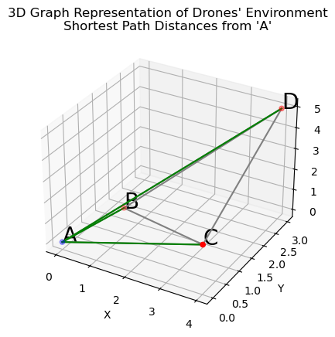

Figure-03

Shortest path distances from node 'A':

* Distance to A: 0.00 units
* Distance to B: 1.73 units
* Distance to C: 4.47 units
* Distance to D: 7.07 units

**Algorithm Execution:**

* + **Dijkstra’s Algorithm:** This algorithm will calculate the shortest path from the UAV’s starting position to the target position, ensuring the minimum travel distance.
  + An algorithm: A more efficient variant that uses heuristics to guide the search, potentially reducing computation time by focusing on more promising paths.

**Steps:**

* Construct the graph based on the environment.
* Apply Dijkstra’s or A* algorithm to find the shortest path.
* The output is the sequence of waypoints the UAV should follow for the shortest path.

**Application in UAV Navigation:**

* **Graph Representation:**

Similar to SFS, represent the environment as a graph.



Figure-04

**Dijkstra’s Algorithm:**

* The algorithm is used to find the shortest path distance between two waypoints.

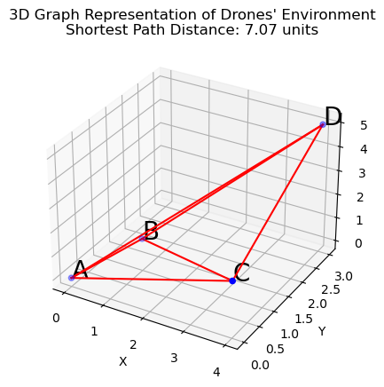

Figure-05

**Explanation:**

**Graph Construction:**

* + The waypoints are represented with 3D coordinates (x, y, z).
  + The graph is created with edges weighted by the Euclidean distance between waypoints.

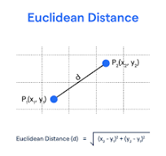

Figure-06

Similarly, to calculate the distance between two objects (or points) in space, the knowledge and formula of three dimensions – the distance between two points is required. PQ = d = √ [(x2 – x1)2 + (y2 – y1)2 + (z2 – z1)2].

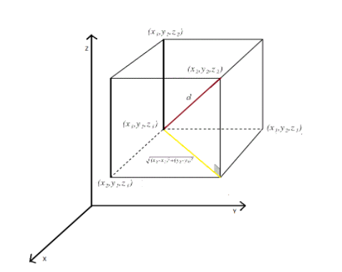

Figure-07

* + Example graph with 3D coordinates (x, y, z)
  + waypoints =
  + 'A': (0, 0, 0),
  + 'B': (1, 1, 1),
  + 'C': (4, 0, 2),
  + 'D': (4, 3, 5)

**3D Visualization:**

* + matplotlib is used to plot the graph in 3D.
  + Nodes are plotted as points, and edges are plotted as lines connecting these points.

**Result:**

* + The shortest path distance is calculated and printed. The shortest path distance between the two drones: 7.07 units
  + The 3D plot is displayed, showing the nodes and edges in the environment.

**Use Case:**

This 3D pathfinding approach is useful for UAVs operating in three-dimensional environments, such as urban areas with tall buildings or natural environments with varying terrain. It ensures that the UAVs can navigate efficiently while accounting for altitude changes.